# CS 255 System Design Document Template

## UML Diagrams

### UML Use Case Diagram

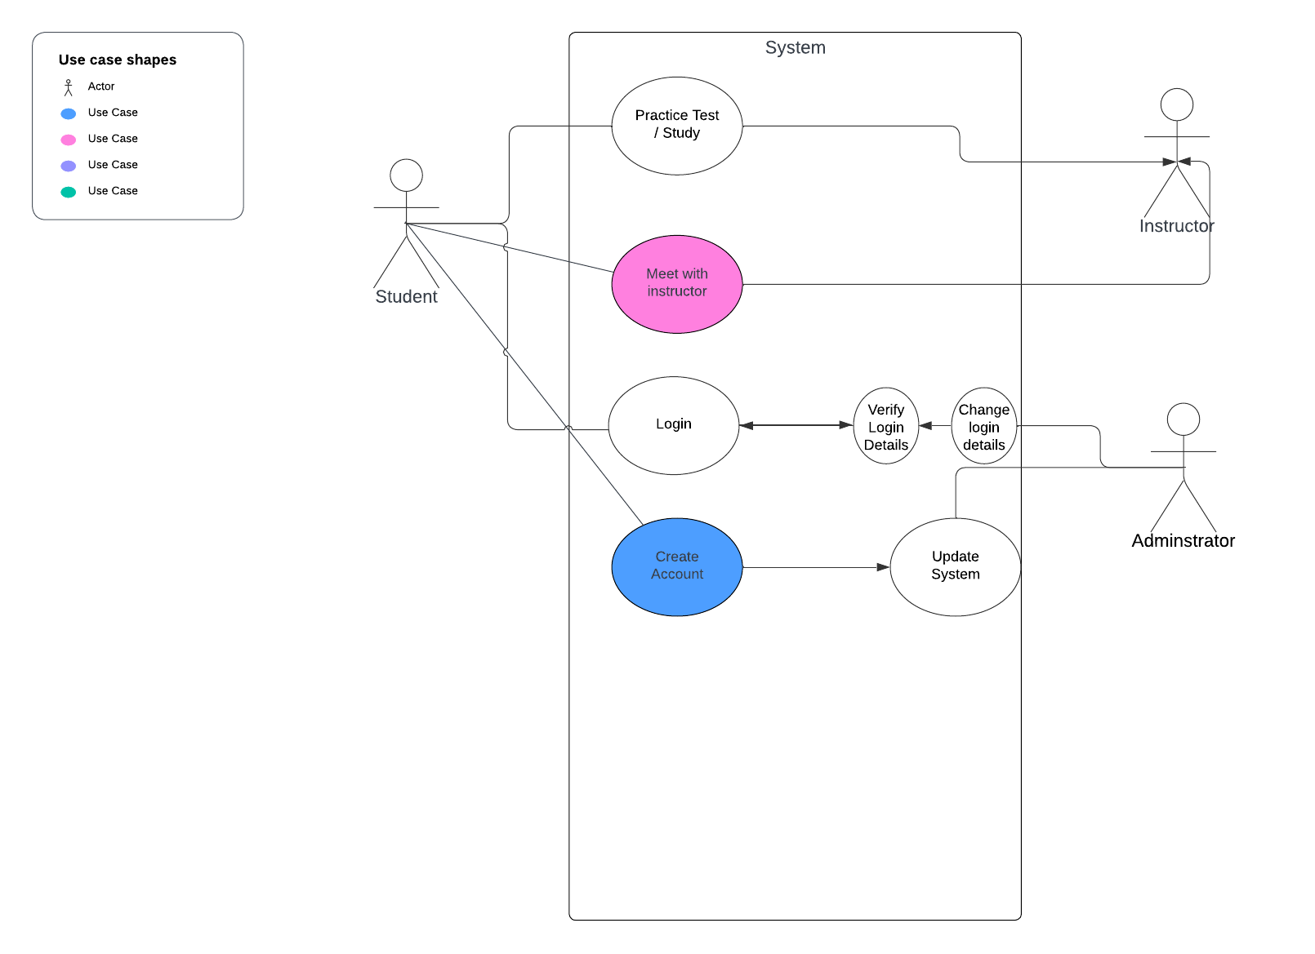

### UML Activity Diagrams

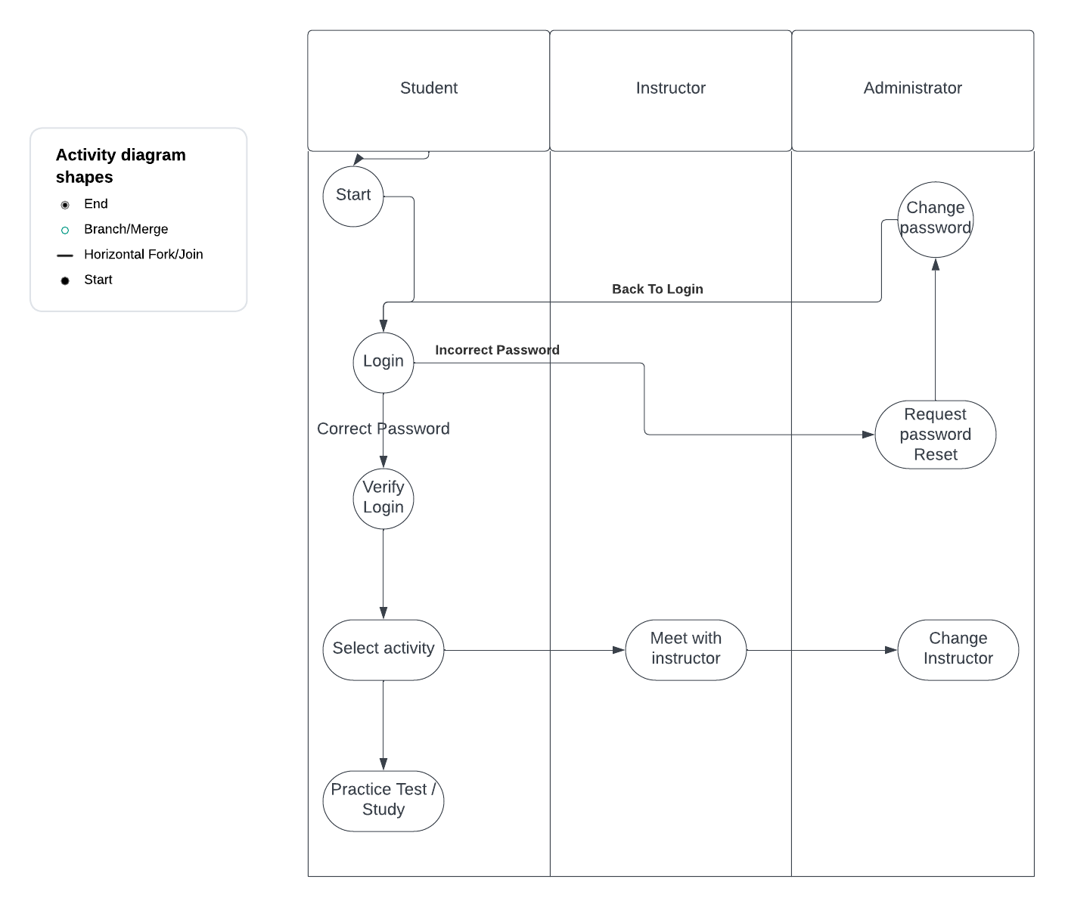

*Example activity diagram of login and general use cases.*

### UML Sequence Diagram

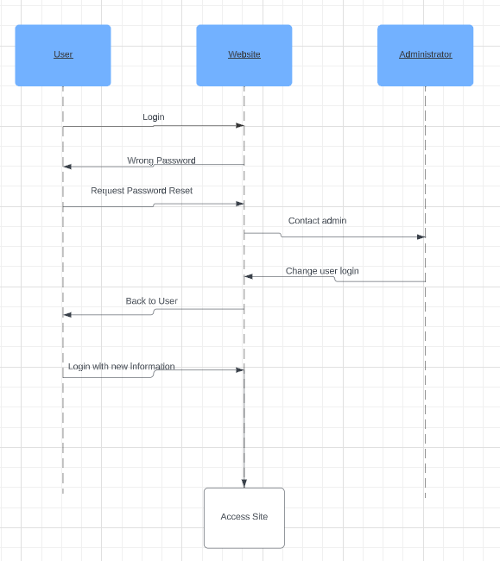

Sequence diagram of user logging in and resetting their password before accessing the rest of the website.

### UML Class Diagram

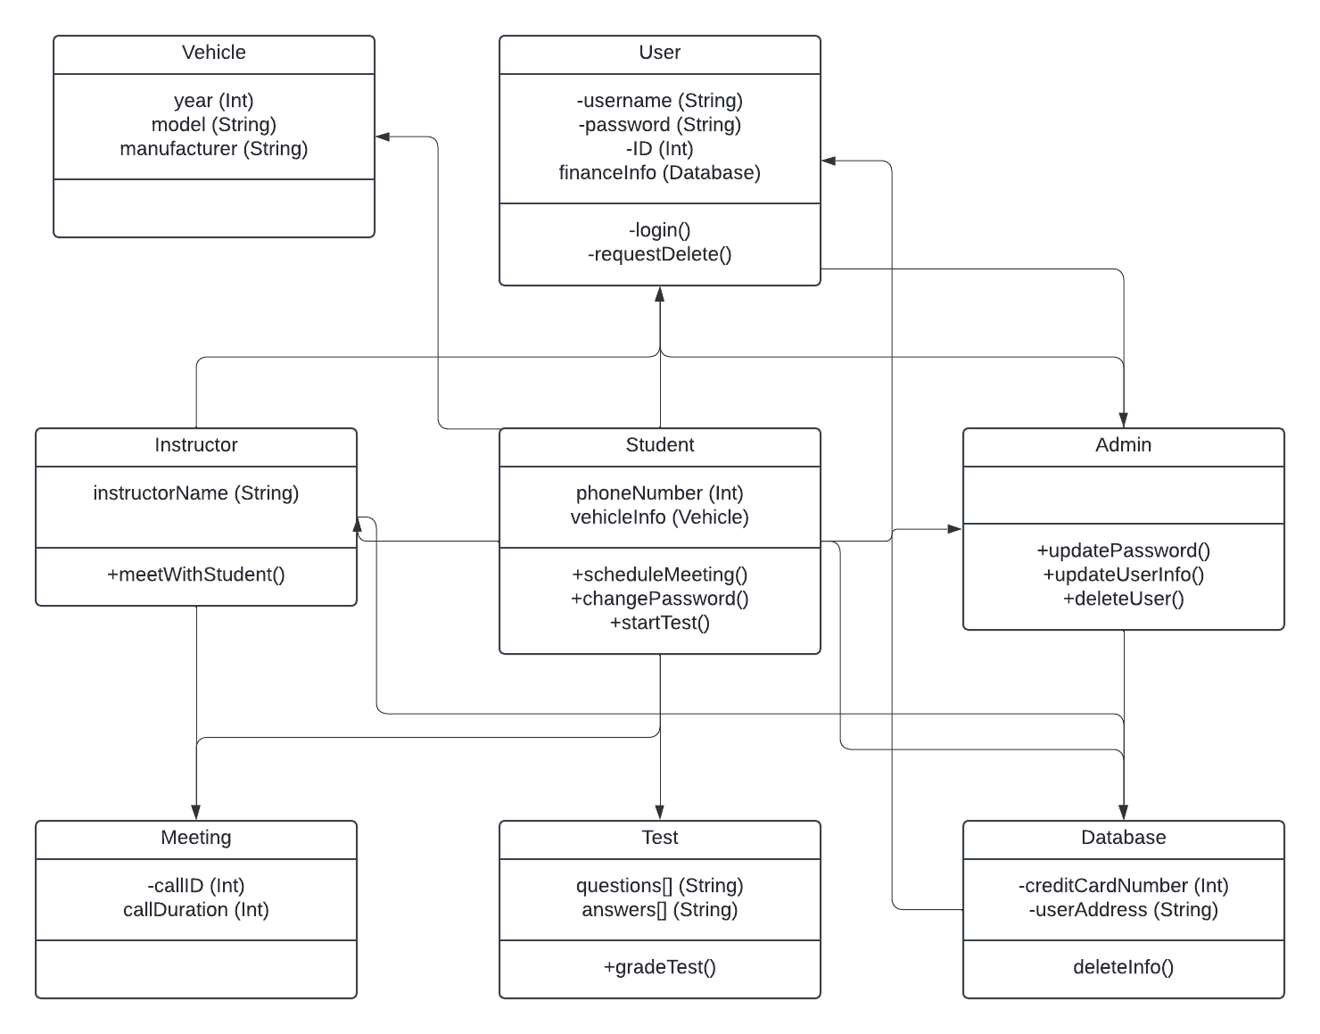

## Technical Requirements

*[Based on the diagrams you have created, describe the technical requirements of your system. These requirements should address the required hardware, software, tools, and infrastructure necessary for your system design.]*

Hardware requirements:

*Server / data base for storing user info, eg address, phone number, passwords, etc.

*Internet access for all users / computers obviously.

Software requirements:

*Website for service

*Test application

*Instructor meet up application